BUSINESS REQUIREMENT DOCUMENT



Building Resilient Commercial Smallholder Agriculture
(BRECSA)
Contents
1. Project Profile Management 5
1.1. PPD User 5
1.2. Project Director (PD) 5
a) Impact, Goal and Objective for Project 6
b) Adding sub-component to the Component 6
c) Linking Output with the Component and sub-component 6
d) Linking Activity with the component, sub-component and Output 7
2. Project Planning 8
2.1. Annual Work Plan and Budget (AWPB) 8
2.1.1 Geog Extension Officer (GAEO, GLEO, EDMO, WFP, PMU) 8
2.1.2 Dzongkhag Agriculture Officer (DAO)/Dzongkhag Livestock Officer (DLO) 11
2.1.3 Physical M&E 11
2.1.4 Financial M&E 12
2.2 Procurement Planning 12
2.2.1 Procurement user 13
3. Progress Report 16
3.1 Physical Progress 16
3.1.1 GAEO/GLEO/WFP/RAMCO/PMU 17
3.1.2 Physical M&E 23
3.2 Financial Progress 24
3.2.1 DFO/ Financial M&E 24
3.2.1.1 Financial expense interface 24
3.2.1.2 Advance Interface 28
3.2.2 Financial M&E 30
4. Annual Outcomes Survey 31
4.1 Project Objective 31
4.2 Project Goal 32
4.3 Project Outreach 32
4.4 Project Outcome 33
4.5 Baseline Survey 33
5. Release 34
6. Configuration 35
6.1 Young Configuration 35
6.2 No. of People in a household 35
7. Project Review 36
7.1 Supervision Mission Report and Observation. 36
7.2 Project mid term review 36
7.3 Audit report and observation 36
7.4 Action Taken Report 37
7.4.1 Supervision Mission Report and Observation 37
7.4.2 Project mid term review 37
7.4.3 Audit report and observation 37
7.5 PSC minutes Recording 38
7.6 Completion Report 38
8. Master Management 39
9. User management 39
9.1 Users 39
10. Report 41
10.1. Geo Level 41
10.1.1 AWPB Proposed Report 41
10.1.2 AWPB Approved Report 41
10.1.3 Physical Progress submitted 41
10.2. DAO level 42
10.2.2 AWPB Approved Report 42
10.2.3 Physical Progress submitted by geog 42
10.2.4 Financial Progress submitted by DFO 43
10.3. DFO level 43
10.3.2 AWPB Approved Report 43
10.3.3 Physical Progress submitted by geog 44
10.3.4 Financial Progress submitted 44
10.4. Physical M&E level 45
10.4.1 AWPB Proposed Report 45
10.4.2 AWPB Approved Report 45
10.4.3 Physical Progress submitted by Geogs 45
10.4.4 Financial Progress submitted 46
10.4.5 Detail of Beneficiaries Report 46
10.4.6 M&E Report (M&E matrix) 46
10.4.7 Outcome Report 47
10.4.8 Outreach Report 47
10.4.9 Objective Report 47
10.4.10 Goal Report 47
10.5 Financial M&E 48
10.5.1 AWPB Proposed Report 48
10.5.2 AWPB Approved Report 48
10.5.3 Physical Progress submitted by Geogs 48
10.5.4 Financial Progress submitted 49
10.5.5 Financial 49
10.5.5.1 SoE Report 49
10.5.5.2 IFR Report 49
10.5.5.2.1 IFAD funds Forecast 49
10.5.5.2.2 Sources and use of fund 50
10.5.5.2.3 Variance analysis Quarter 50
10.5.5.2.4 Variance analysis Financial Year 50
10.5.5.2.5 Variance analysis cumulative 50
10.5.6 Procurement plan 51
10.5 PPD level (same like M&E) 51
10.6 Management level (Dashboard only) 51
11. Annexure 53

Project Profile Management

PPD User

Business Requirement 1.1

BR No. | Business Requirement
1.1.1 | PPD User should have a feature to create project, on behalf of project managements
1.1.2 | Once the project has been created PPD should be able to create Project Director(PD) user against that project.
1.1.3 | The PD user will have a right to create the users under that project.

Field Name | Input Type | Validation | Remarks
Project name | Text

Project Director (PD)

Business Requirement 1.2

BR No. | Business Requirement
1.2.1 | PD should be able to add project details against the project created.
1.2.2 | PD and M&E users should have access to add items in the masters for their projects.
1.2.3 | Followings are the details:

Input form

Impact, Goal and Objective for Project
Field Name | Input Type | Validation | Remarks
Project name | Auto
Impact | long text
Goal | long text
Development Objectives | Long text

Adding sub-component to the Component

Add more
Component | Select | Pull from masters | Component and Sub-component mapping
Sub-component | Select | Pull from masters | Component and Sub-component mapping
End of Add more

Linking Output with the Component and sub-component

Add more

Component | Select | Pull from masters
Sub-component | Select | Pull from masters
Output | Select | Pull from masters
End of Add more

Linking Activity with the component, sub-component and Output

Add More

Component | Select | Pull from masters
Sub-component | Select | Pull from masters
Output | Select | Pull from masters
Activity | Select | Pull from masters

End of Add more

BR No. | Business Requirement
1.2.3 | should have a “Save as Draft” and save feature

Project Planning

2.1. Annual Work Plan and Budget (AWPB)

Process flow

Start
Geog
DAO
M&E
Stop
Notify

2.1.1 Geog Extension Officer (GAEO, GLEO, EDMO, WFP, PMU)

BR No. | Business Requirement
2.1.1.1 | There should be a feature to submit the Annual Work Plan.
2.1.1.2 | Upon submission, the application should be forwarded to the DAO or DLO, or M&E depending on the structure (Annexure Structure).
2.1.1.3 | The submission is only once in a Financial Year.

Input form
add more
Field Name | Input Type | Validation | Remarks
Financial Year | Select | Pull from Master
Sector | Select | Pull from Master
Component | Select | Pull from Master
Sub-component | Select | Pull from Master
Output | Select | Pull from Master
Activity | Select | Pull from Master
Sub-Activity | Long Text
Indicator | Long Text
Quantity Planned | Number
Household | Number
Male (M) | Number
Female (F) | Number
Total Beneficiaries | Auto (M+F)
Category | Select | Pull from Master
GAFSP(A) | Number
IFAD Loan (B) | Number
RGoB (C) | Number
Beneficiary (D) | Number
Total | Auto (A+B+C+D) | Formula
Quarter | Select | Pull from masters
Location | Text
Collaborator | Text
Procurement Option | Select | Pull from masters
Procurement Method | Select | Pull from masters
Procurement Plan (PP) Review | Select | Pull from masters
Procurement Item | Text
RGoB OBC code | Select | Pull from masters
AWPB PP code | Text
Remarks | Text
Status | Auto | by default it should be Proposal
Save Draft | Button
Submit | Button

end of add more

2.1.2 Dzongkhag Agriculture Officer (DAO)/Dzongkhag Livestock Officer (DLO)

BR No. | Business Requirement
2.1.2.1 | Should be able to view all the applications submitted by the geogs under that Dzongkhag.
2.1.2.2 | Should have edit and forward (to M&E) buttons.
2.1.2.3 | Should be able to edit all the fields.
2.1.2.4 | Should have a reject button against each sub-activity proposed. while rejecting the corresponding sub-activity should be deleted from the system.

2.1.3 Physical M&E

BR No. | Business Requirement
2.1.3.1 | Should be able to view all the applications from 205 Geogs.
2.1.3.2 | Should be able to edit all the details.
2.1.3.3 | Should have approve and reject buttons
2.1.3.4 | There should be status selection before approving. The status updated by Physical M&E against the proposal application should update all the status down the line.
2.1.3.5 | Upon approving the application, notify respective Geogs and Dzongkhags through system dashboard and email.
2.1.3.6 | If rejected, the proposed sub-activity should be deleted from the system.
2.1.3.7 | Should be able to download in Word, PDF, and Excel formats.

2.1.4 Financial M&E

BR No. | Business Requirement
2.1.3.1 | Should be able to view all the applications from 205 Geogs.
2.1.3.7 | Should be able to download in Word, PDF, and Excel formats.

2.2 Procurement Planning

start
Procurement
Physical M&E
Financial M&E
Share report

2.2.1 Procurement user

BR No. | Business Requirement
2.2.1 | Should have an interface from where the procurement plan can be derived based on the plan submitted by the Geogs. With filters “Category (goods, services, and works), Dzongkhag,Geog, sector PP Method and PP Review”.
2.2.2 | Should be able to download in PDF, Word, and Excel format.

Input Form
Field Name | Input Type | Validation | Remarks
Profile Information
Agency | Auto | use Dzongkhag of the user as agency
Sector | Auto
Component | Auto
Sub-component | Auto
Category | Auto
Activity | Auto
Sub-Activity | Auto
IFAD Loan (A) | Auto
GAFSP (B) | Auto
Total | Auto (A+B)
Implementing Quarter | Auto
Procurement Method | Auto
Procurement Plan (PP) Review | Auto

Field Name | Input Type | Validation | Remarks
Basic Data
Package/Lot No | Select | Pull from masters
Pre or Post Qualification | Select
Plan vs Actual | Select | Pull from masters
Pre. Qualification
Preparation of Pre Qual docs | Text
No Objection Date (PreQual docs) | Date
PreQual Invitation Date | Date
PreQual Closing date | Date
No Objection Date (PreQual Report) | Date
Bidding process
No Objection Date | Date
Bid Invitation date | Date
Bid Closing/Opening | Date
Bid Evaluation
Submission of Technical Evaluation report | Text
No objection Date | date
Submission Combined Evaluation report | Text
No-Objection Date | date
Plan Vs Actual | Select | Pull from masters
Contract Award and Signature
Date of Contract Award | Date
Date of Contract Signature | Date
MoF’s Directive | Text
Save as Draft | Button
Save | Button

BR No. | Business Requirement
2.2.3 | There should be an interface to upload files for all the select options available under “Package/Lot No” as follows.

Input form
Field Name | Input Type | Validation | Remarks
File upload
Package/Lot No | Select | Pull from masters
Submission of Pre-Qual Report | file upload
Bid document | file upload
Submission of Technical Evaluation report | file upload

Progress Report

3.1 Physical Progress

Start
GEO
M&E
End
DFO
Share
Process flow

3.1.1 GAEO/GLEO/WFP/RAMCO/PMU
BR No. | Business Requirement
3.1.1.1 | There should be a physical reporting feature against each approved sub-activity in the AWPB.

Input form
Project Activity Detail
Field Name | Input Type | Validation | Remarks
Financial Year | Auto
Sector | Auto
Component | Auto
Sub-component | Auto
Output | Auto
Activity | Auto
Sub-Activity | Auto
Indicator | Auto
Quantity Planned | Auto
Household | Auto
Male (M) | Auto
Female (F) | Auto
Total Beneficiaries | Auto
Category | Auto
GAFSP (A) | Auto
IFAD Loan (B) | Auto
RGoB (C) | Auto
Beneficiary (D) | Auto
Total | Auto
Quarter | Auto
Location | Auto
Collaborator | Auto

Input Form
Selection
Field Name | Input Type | Validation | Remarks
Beneficiary Type | Select (individual or Group) | Pull from masters

If Individual
Field Name | Input Type | Validation | Remarks
Bio Data
CID | Number
Name | Auto | Pull from DCRC
Village | Auto | Pull from DCRC
Geog | Auto | Pull from DCRC
Dzongkhag | Auto | Pull from DCRC
Gender | Auto | Pull from DCRC
House No | Auto | Pull from DCRC
Support provided | Select
Present Address
Dzongkhag | Select | Pull from masters
Geog | Select | Pull from masters
Village | Select | Pull from masters
Disable | Radio Button | Yes/No
Climate resilient Technology | Radio button | Yes/No
if Yes(Climate resilient Technology) if no nothing addition to capture
Type | Select | Pull from masters
Count: | Number
Unit | Select | Pull from masters
end of if yes (Climate resilient Technology)
Access to Finance | Radio button | Yes/No
if Yes(Access to Finance) if no nothing addition to capture
Bank name | Select | Pull from master
Amount | Number
Remarks | Text
end of if yes(Access to Finance)

end of If individual

Field Name | Input Type | Validation | Remarks
Quantity Achieved | Number
Unit | Select | Pull from Master

If Group (add all members)

Field Name | Input Type | Validation | Remarks
Group [old or new] | Select (old or new) | Pull from masters

Add more
Field Name | Input Type | Validation | Remarks
Bio Data
CID | Number
Name | Auto | Pull from DCRC
Village | Auto | Pull from DCRC
Geog | Auto | Pull from DCRC
Dzongkhag | Auto | Pull from DCRC
Gender | Auto | Pull from DCRC
Household No | Auto | Pull from DCRC
Head of household | Auto (yes or No)
Support provided | Select | Pull from masters
Present Address
Dzongkhag | Select | Pull from masters
Geog | Select | Pull from masters
Village | Select | Pull from masters
Disable | Radio Button | Yes/No
Climate resilient Technology | Radio button | Yes/No
if Yes(Climate resilient Technology) if no nothing addition to capture
Type | Select | Pull from masters
Count: | Number
Unit | Select | Pull from masters
end if Yes(Climate resilient Technology)
Access to Finance | Radio button | Yes/No
if Yes (Access to Finance) if no nothing addition to capture
Bank name | Select | Pull from master
Amount | Number
Remarks | Text
end of if Yes (Access to Finance)
Group Name | Text
Membership | Select (Chairman or member) | Pull from masters
end of If
end of add more

Field Name | Input Type | Validation | Remarks
Quantity Achieved | Number
Unit | Select | Pull from Master

Summary of members added
Field Name | Input Type | Validation | Remarks
HouseHold Headed by women | Auto (total number of HouseHold Headed by women)
Disability | Auto ( number of disabled member in a group)
Male (M) | Auto (Total male members)
Female (F) | Auto (Female members)
Young | Auto (Youth male + Female members) |  | Those whose age is less than the age configured in the Configuration module will fall under young.
Total | Auto (M + F)
Land Bought under climate resilient management in Acre | Auto ( total of all Acreage)
end of If Group

BR No. | Business Requirement
3.1.1.2 | There should be a “Save as Draft” feature
3.1.1.3 | Upon submission, the application should be forwarded to M&E and a copy to DFO.

3.1.2 Physical M&E

BR No. | Business Requirement
3.1.2.1 | Should be able to view the Physical progress submitted by GEO.
3.1.2.2 | Should be able to edit the progress based on the physical inspection done by the M&E.

3.2 Financial Progress

Start
DFO
M&E
End

Process flow

3.2.1 DFO/ Financial M&E

3.2.1.1 Financial expense interface
BR No. | Business Requirement
3.2.1.1.1 | There should be a financial reporting feature to report Financial progress against each physical progress submitted by Geog
3.2.1.1.2 | Financial Reporting will be enabled only against those activities whose physical progress report has been submitted.
3.2.1.1.3 | Use Accordion

Input form
AWPB Details ( - )
Field Name | Input Type | Validation | Remarks
Financial Year | Auto
Sector | Auto
Component | Auto
Sub-component | Auto
Output | Auto
Activity | Auto
Sub-Activity | Auto
Category | Auto
IFAD | Auto
Loan | Auto
RGoB | Auto
BEN | Auto
RGoB OBC code | Auto
Remarks | Auto
Agencies | Auto

Physical Progress Details ( - )

Field Name | Input Type | Validation | Remarks
CID | Auto
Name | Auto
Village | Auto
Geog | Auto
Dzongkhag | Auto
Gender | Auto
House No | Auto
Support provided | Auto
Type | Auto
Quantity | Auto
Unit | Auto
Count | Auto
Disability | Auto
Woman Headed Household | Auto
Name of a group | Auto
Commodity | Auto

Financial progress
Field Name | Input Type | Validation | Remarks
Full Description of Payment | Text
Name of the Payee/ Contractor, Supplier, Service Provider | Text
Contract and/or Invoice Number /Note Sheet No | Text
Vouchers no. | Text
Amount (A) | Number
Tax Amount | Number
Advance | radio button | yes/ no | if yes then the amount should not be booked as expenditure, rather the application should be moved to the Advance interface.
Date of Payment | Select | Cannot accept future date | if advance is no
Date of Advance | Select | Cannot accept future date | if advance is yes
Exchange rate (ER) | Text
Withdrawal Application  Currency  (USD Dollar ) | Auto | Formula ( ER / A)
Payment Reference to Bank Account or Cash Book (e.g. value date or transaction ID)/ Cheque number | Text
Submit | Button

BR No. | Business Requirement
3.2.1.1.4 | There should be a “Save as Draft” feature
3.2.1.1.5 | Upon submission, the application should be forwarded to Financial M&E.
3.2.1.1.6 | If the advance is YES, the Submit button should be disabled and “Book Advance” button should be enabled
3.2.1.1.7 | If the advance is NO, the Submit button should be enabled and the amount should be booked as expenditure.
3.2.1.1.8 | If the “Book Advance” Button is clicked then the amount should not be booked as expenditure, rather the application should be moved to the Advance Adjustment interface.

3.2.1.2 Advance Interface

BR No. | Business Requirement
3.2.1.2.1 | All the applications that are booked as Advance should be displayed.
3.2.1.2.2 | There should be an “adjust the advance” button against all the applications booked as advance, while adjusting the advance there should be a field to capture whether the adjustment is “full adjustment” or “Partial adjustment”.

Field Name | Input Type | Validation | Remarks
Adjustment Type | Select (Partial Adjustment or Full Adjustment)
Full Description of Payment | Text
Name of the Payee/ Contractor, Supplier, Service Provider | Text
Contract and/or Invoice Number /Note Sheet No | Text
Vouchers no. | Text
Amount (A) | Number | should be not more that the advance amount
Tax Amount | Number
Date | Select | Cannot accept future date
Exchange rate (ER) | Text
Withdrawal Application  Currency  (USD Dollar ) | Auto | Formula ( ER / A)
Payment Reference to Bank Account or Cash Book (e.g. value date or transaction ID)/ Cheque number | Text
Submit | Button

BR No. | Business Requirement
3.2.1.2.3 | If Partial advance adjustment is selected, compare the advance amount with the current adjustment amount. The difference of the advance amount with the current adjustment amount should be kept in the advance interface until the “Full adjustment” is selected, and the “current adjustment” amount should be booked as expenditure.
3.2.1.2.4 | If Full adjustment is selected no matter what the amount is it should be booked as expenditure, and remove the application from Advance interface.

3.2.2 Financial M&E

BR No. | Business Requirement
3.2.2.1 | Should be able to view and edit the progress submitted by DFO.
3.2.2.2 | Should be able to view the physical progress submitted by PMU,WFP, RAMCO users and accordingly Financial M&E should report financial progress for those Physical progress.
3.2.2.3 | Report should be downloadable in PDF, Word and Excel formats.

Annual Outcomes Survey

Outcome Indicator Survey
BR No. | Business Requirement
4 | This module is only for M&E.

4.1 Project Objective

Add more
Field Name | Input Type | Validation | Remarks
Core indicator | Select | Pull from masters | Core indicator and indicator mapping
Indicator | Select | Pull from masters | Core indicator and indicator mapping
Indicator Description | Text
Unit | Select | Pull from masters
Baseline | Number
Target | Number
Annual Progress | Number

end of add more

4.2 Project Goal

Add more
Field Name | Input Type | Validation | Remarks
Core indicator | Select | Pull from masters | Core indicator and indicator mapping
Indicator | Select | Pull from masters | Core indicator and indicator mapping
Indicator Description | Text
Unit | Select | Pull from masters
Baseline | Number
Target | Number
Annual Progress | Number

end of addmore

4.3 Project Outreach

Add more
Field Name | Input Type | Validation | Remarks
Core indicator | Select | Pull from masters | Core indicator and indicator mapping
Indicator | Select | Pull from masters | Core indicator and indicator mapping
Indicator Description | Text
Unit | Select | Pull from masters
Baseline | Number
Target | Number

end of add more

4.4 Project Outcome

Add more
Field Name | Input Type | Validation | Remarks
Core indicator | Select | Pull from masters | Core indicator and indicator mapping
Indicator | Select | Pull from masters | Core indicator and indicator mapping
Indicator Description | Text
Unit | Select | Pull from masters
Baseline | Number
Target | Number

end of add more

4.5 Baseline Survey

Add more
Field Name | Input Type | Validation | Remarks
Core indicator | Select | Pull from masters | Core indicator and indicator mapping
Indicator | Select | Pull from masters | Core indicator and indicator mapping
Indicator Description | Text
Unit | Select | Pull from masters
Baseline | Number
Target | Number

end of add more

Release

Field Name | Input Type | Validation | Remarks
Country | Auto
Name of Project | Auto
IFAD Instrument number | Text
List other instruments if applicable | Text
Expressed in Designated Account Denomination Currency | Select | pull from masters

Configuration

6.1 Young Configuration

Field Name | Input Type | Validation | Remarks
DoB | Date
save | button

6.2 No. of People in a household

Field Name | Input Type | Validation | Remarks
Average No. of Person in Household | Number
save | button

Project Review

7.1 Supervision Mission Report and Observation.

Field Name | Input Type | Validation | Remarks
Report | File upload
Remarks | Long Text
save | button

7.2 Project mid term review

Field Name | Input Type | Validation | Remarks
Report | File upload
Remarks | Long Text
save | button

7.3 Audit report and observation

Field Name | Input Type | Validation | Remarks
Report | File upload
Remarks | Long Text
save | button

7.4 Action Taken Report

7.4.1 Supervision Mission Report and Observation

Field Name | Input Type | Validation | Remarks
Report | File upload
Remarks | Long Text
save | button

7.4.2 Project mid term review

Field Name | Input Type | Validation | Remarks
Report | File upload
Remarks | Long Text
save | button

7.4.3 Audit report and observation

Field Name | Input Type | Validation | Remarks
Report | File upload
Remarks | Long Text
save | button

7.5 PSC minutes Recording

Field Name | Input Type | Validation | Remarks
PSC meeting | Text
Minutes | File upload
Remarks | Long Text
save | button

7.6 Completion Report

Field Name | Input Type | Validation | Remarks
Report | File upload
Remarks | Long Text
save | button

Master Management

Business Requirement 8
BR No. | Business Requirement
8.1 | All the fields in the input forms which have the “select” option should be managed from the masters.
8.2 | In the masters there should add feature
8.3 | There should be a disabled feature (entry once made in the master cannot not be deleted, instead disabled), once disabled it should not be viewable in the input forms under the select option.
8.4 | There should be enable Feature (enable the disabled entry)

User management

9.1 Users
- Admin
- Project Director
- Physical M&E
- Finance M&E
- DFO
- DAO/DLO
- GAEO/GLEO/WFP/RAMCO/PMU
- Management
- PMU Procurement

Input form
Field Name | Input Type | Validation | Remarks
Project Name | select
Name | Text
Employee ID | Text
Designation | Select
Dzongkhag | Select
Geog | Select
Sector | Select
Role | Multi-select
create user | Button

Business Requirement 9
BR No. | Business Requirement
9.1 | Refer annexure organizational structure

Report

10.1. Geo Level

10.1.1 AWPB Proposed Report

BR No. | Business Requirement
10.1.1.1 | Should be able to view the proposed AWPB by the user.
10.1.1.2 | Should have “from date” and “to date” and all other possible filters based on the AWPB input form.
10.1.1.3 | Report should be downloadable in PDF, Word and Excel formats.

10.1.2 AWPB Approved Report

BR No. | Business Requirement
10.1.2.1 | Should be able to view the Approved AWPB
10.1.2.2 | Should have “from date” and “to date” and all other possible filters based on the AWPB input form.
10.1.2.3 | Report should be downloadable in PDF, Word and Excel formats.

10.1.3 Physical Progress submitted

BR No. | Business Requirement
10.1.2.1 | Should be able to view the Physical progress submitted
10.1.2.2 | Should have “from date” and “to date” and all other possible filters based on the AWPB input form.
10.1.2.3 | Report should be downloadable in PDF, Word and Excel formats.

10.2. DAO level

10.2.1 AWPB Proposed Report
BR No. | Business Requirement
10.2.1.1 | Should be able to view the proposed AWPB by the Geog users under his dzongkhag.
10.2.1.2 | Should have “from date” and “to date” , geog wise, and all other possible filters based on the AWPB input form.
10.2.1.3 | Report should be downloadable in PDF, Word and Excel formats.

10.2.2 AWPB Approved Report

BR No. | Business Requirement
10.2.2.1 | Should be able to view the Approved AWPB under his dzongkhag
10.2.2.2 | Should have “from date” and “to date”, geog wise and all other possible filters based on the AWPB input form.
10.2.2.3 | Report should be downloadable in PDF, Word and Excel formats.

10.2.3 Physical Progress submitted by geog

BR No. | Business Requirement
10.2.3.1 | Should be able to view the Physical progress submitted by geogs under that dzongkhag
10.2.3.2 | Should have “from date” and “to date” and all other possible filters based on the AWPB input form.
10.2.3.3 | Report should be downloadable in PDF, Word and Excel formats.

10.2.4 Financial Progress submitted by DFO

BR No. | Business Requirement
10.2.4.1 | Should be able to view the Financial progress submitted by DFO under his dzongkhag
10.2.4.2 | Should have “from date” and “to date” and all other possible filters based on the AWPB input form.
10.2.4.3 | Report should be downloadable in PDF, Word and Excel formats.

10.3. DFO level

10.3.1 AWPB Proposed Report
BR No. | Business Requirement
10.3.1.1 | Should be able to view the proposed AWPB by the Geog users under his dzongkhag.
10.3.1.2 | Should have “from date” and “to date” , geog wise, and all other possible filters based on the AWPB input form.
10.3.1.3 | Report should be downloadable in PDF, Word and Excel formats.

10.3.2 AWPB Approved Report

BR No. | Business Requirement
10.3.2.1 | Should be able to view the Approved AWPB under his dzongkhag
10.3.2.2 | Should have “from date” and “to date”, geog wise and all other possible filters based on the AWPB input form.
10.3.2.3 | Report should be downloadable in PDF, Word and Excel formats.

10.3.3 Physical Progress submitted by geog

BR No. | Business Requirement
10.3.3.1 | Should be able to view the Physical progress submitted by geogs under that dzongkhag
10.3.3.2 | Should have “from date” and “to date” and all other possible filters based on the AWPB input form.
10.3.3.3 | Report should be downloadable in PDF, Word and Excel formats.

10.3.4 Financial Progress submitted

BR No. | Business Requirement
10.2.4.1 | Should be able to view the Financial progress submitted
10.2.4.2 | Should have “from date” and “to date”, gewog wise, and all other possible filters based on the AWPB input form.
10.2.4.3 | Report should be downloadable in PDF, Word and Excel formats.

10.4. Physical M&E level

10.4.1 AWPB Proposed Report

BR No. | Business Requirement
10.4.1.1 | Should be able to view the proposed AWPB by the 205 Geog users
10.4.1.2 | Should have “from date” and “to date”, geog wise, and all other possible filters based on the AWPB input form.
10.4.1.3 | Report should be downloadable in PDF, Word, and Excel formats.

10.4.2 AWPB Approved Report

BR No. | Business Requirement
10.4.2.1 | Should be able to view the Approved AWPB
10.4.2.2 | Should have “from date” and “to date”, Dzongkhag wise, geog wise and all other possible filters based on the AWPB input form.
10.4.2.3 | Report should be downloadable in PDF, Word, and Excel formats.

10.4.3 Physical Progress submitted by Geogs

BR No. | Business Requirement
10.4.3.1 | Should be able to view the Physical progress submitted by 205 geogs
10.4.3.2 | Should have “from date” and “to date”, dzongkhag wise, geog wise and all other possible filters based on the AWPB input form.
10.4.3.3 | Report should be downloadable in PDF, Word and Excel formats.

10.4.4 Financial Progress submitted

BR No. | Business Requirement
10.4.4.1 | Should be able to view the Financial progress submitted
10.4.4.2 | Should have “from date” and “to date”, gewog wise, and all other possible filters based on the AWPB input form.
10.4.4.3 | Report should be downloadable in PDF, Word and Excel formats.

10.4.5 Detail of Beneficiaries Report

BR No. | Business Requirement
10.4.5.1 | Should be able to view the beneficiaries
10.4.5.2 | Should have “from date” and “to date”, gewog wise, and all other possible filters based on the Physical Progress input form.
10.4.5.3 | Report should be downloadable in PDF, Word and Excel formats.
10.4.5.4 | Refer annexure Beneficiaries Report format.

10.4.6 M&E Report (M&E matrix)

BR No. | Business Requirement
10.4.6.1 | Refer annexure M&E Report format.
10.4.6.2 | For over all count it should be total of Unique CID in all component
10.4.6.3 | Report should be downloadable in PDF, Word and Excel formats.

10.4.7 Outcome Report

BR No. | Business Requirement
10.4.7.1 | Refer annexure outcome survey Report format.
10.4.7.2 | Report should be downloadable in PDF, Word and Excel formats.

10.4.8 Outreach Report

BR No. | Business Requirement
10.4.8.1 | Refer annexure outreach Report format.
10.4.8.2 | The annual progress column should display the cumulative figure from physical Progress for the FY
10.4.8.2 | Report should be downloadable in PDF, Word and Excel formats.

10.4.9 Objective Report

BR No. | Business Requirement
10.4.7.1 | Refer annexure Project objective Report format.
10.4.7.2 | Report should be downloadable in PDF, Word and Excel formats.

10.4.10 Goal Report

BR No. | Business Requirement
10.4.7.1 | Refer annexure Goal Report format.
10.4.7.2 | Report should be downloadable in PDF, Word and Excel formats.

10.5 Financial M&E

10.5.1 AWPB Proposed Report

BR No. | Business Requirement
10.5.1.1 | Should be able to view the proposed AWPB by the 205 Geog users
10.5.1.2 | Should have “from date” and “to date”, geog wise, and all other possible filters based on the AWPB input form.
10.5.1.3 | Report should be downloadable in PDF, Word, and Excel formats.

10.5.2 AWPB Approved Report

BR No. | Business Requirement
10.5.2.1 | Should be able to view the Approved AWPB
10.5.2.2 | Should have “from date” and “to date”, Dzongkhag wise, geog wise and all other possible filters based on the AWPB input form.
10.5.2.3 | Report should be downloadable in PDF, Word, and Excel formats.

10.5.3 Physical Progress submitted by Geogs

BR No. | Business Requirement
10.5.3.1 | Should be able to view the Physical progress submitted by 205 geogs
10.5.3.2 | Should have “from date” and “to date”, dzongkhag wise, geog wise and all other possible filters based on the AWPB input form.
10.5.3.3 | Report should be downloadable in PDF, Word and Excel formats.

10.5.4 Financial Progress submitted

BR No. | Business Requirement
10.5.4.1 | Should be able to view the Financial progress submitted
10.5.4.2 | Should have “from date” and “to date”, gewog wise, and all other possible filters based on the AWPB input form.
10.5.4.3 | Report should be downloadable in PDF, Word and Excel formats.

10.5.5 Financial

10.5.5.1 SoE Report

BR No. | Business Requirement
10.5.5.1.1 | Refer annexure SoE Report format.
10.5.5.1.2 | Report should be downloadable in PDF, Word and Excel formats.

10.5.5.2 IFR Report

10.5.5.2.1 IFAD funds Forecast

BR No. | Business Requirement
10.5.5.2.1.1 | Refer annexure IFAD funds Forecast Report format.
10.5.5.2.1.2 | Report should be downloadable in PDF, Word and Excel formats.

10.5.5.2.2 Sources and use of fund

BR No. | Business Requirement
10.5.5.2.2.1 | Refer annexure Sources and use of Fund Report format.
10.5.5.2.2.2 | Report should be downloadable in PDF, Word and Excel formats.

10.5.5.2.3 Variance analysis Quarter

BR No. | Business Requirement
10.5.5.2.3.1 | Refer annexure Variance analysis Quarter Report format.
10.5.5.2.3.2 | Report should be downloadable in PDF, Word and Excel formats.

10.5.5.2.4 Variance analysis Financial Year

BR No. | Business Requirement
10.5.5.2.4.1 | Refer annexure Variance analysis FY Report format.
10.5.5.2.4.2 | Report should be downloadable in PDF, Word and Excel formats.

10.5.5.2.5 Variance analysis cumulative

BR No. | Business Requirement
10.5.5.2.5.1 | Refer annexure Variance analysis cumulative Report format.
10.5.5.2.5.1 | Report should be downloadable in PDF, Word and Excel formats.

10.5.6 Procurement plan

BR No. | Business Requirement
10.5.6.1 | Should be able to view the Procurement Plan for the 205 Geog users
10.5.6.2 | Should have “from date” and “to date” , geog wise, and all other possible filters based on the Procurement Plan input form.
10.5.6.3 | Report should be downloadable in PDF, Word and Excel formats.

10.5 PPD level (same like M&E)

BR No. | Business Requirement
10.5.1.1 | PPD user should have report of both the M&E Physical and M&E financial

10.6 Management level (Dashboard only)

BR No. | Business Requirement
10.6.1 | Graph -> Dzongkhag wise component outlay
10.6.2 | Graph -> Dzongkhag wise component expenditure
10.6.3 | Table -> See below

Beneficary | Target | Achieved
Beneficary | Target | FY 1 | FY2 | FY 3 | FY4 | FY5 | FY6 | FY7
Male
Female
Disability
Young
Cooperative
Total HouseHold

Description | AMT
Approved Fund
Fund Release
Expenditure

Annexure

Annexure Structure
- AWPB

M&E Physical
DAO
DLO
GAEO
PMU
RAMCO
GLEO
WFP

- Physical Progress

M&E Physical
DAO
DLO
GAEO
PMU
RAMCO
GLEO
WFP

- Financial Progress

M&E Financial
DFO

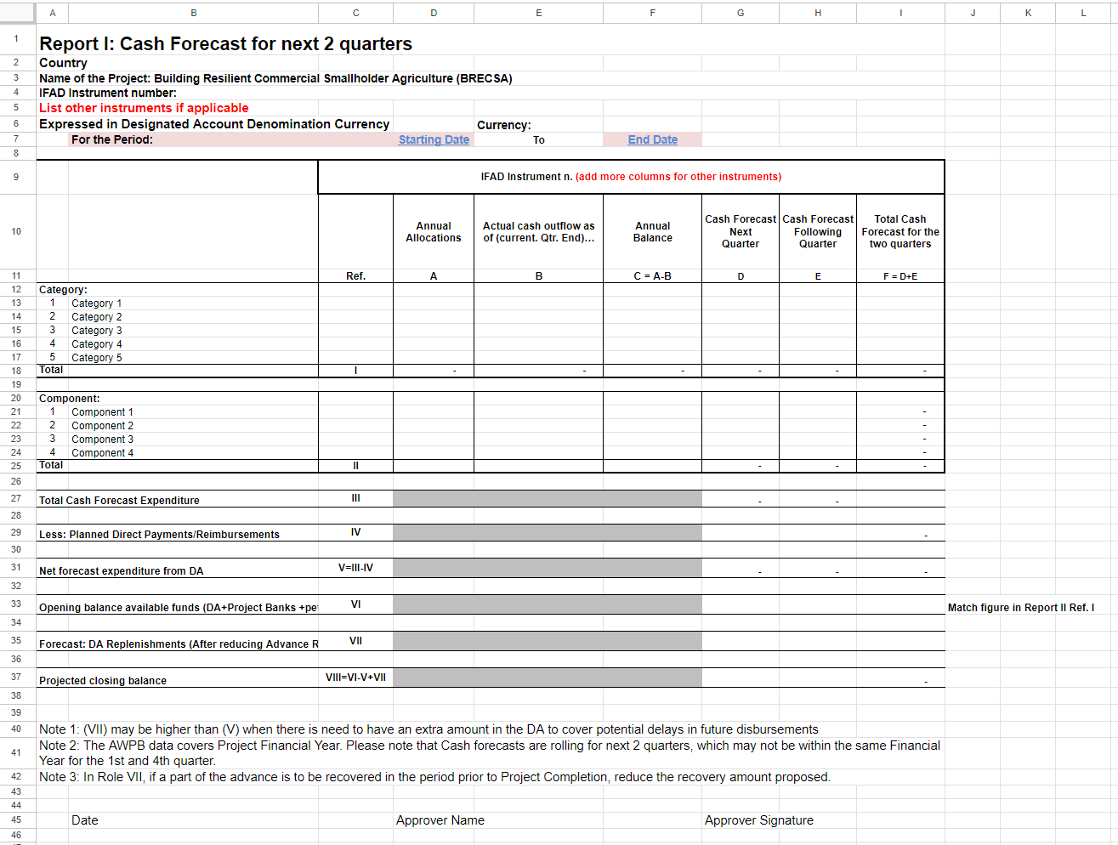
Annexure IFAD Funds-Cash Forecast

Start Date and End Date Will be manually entered and the report should be generated

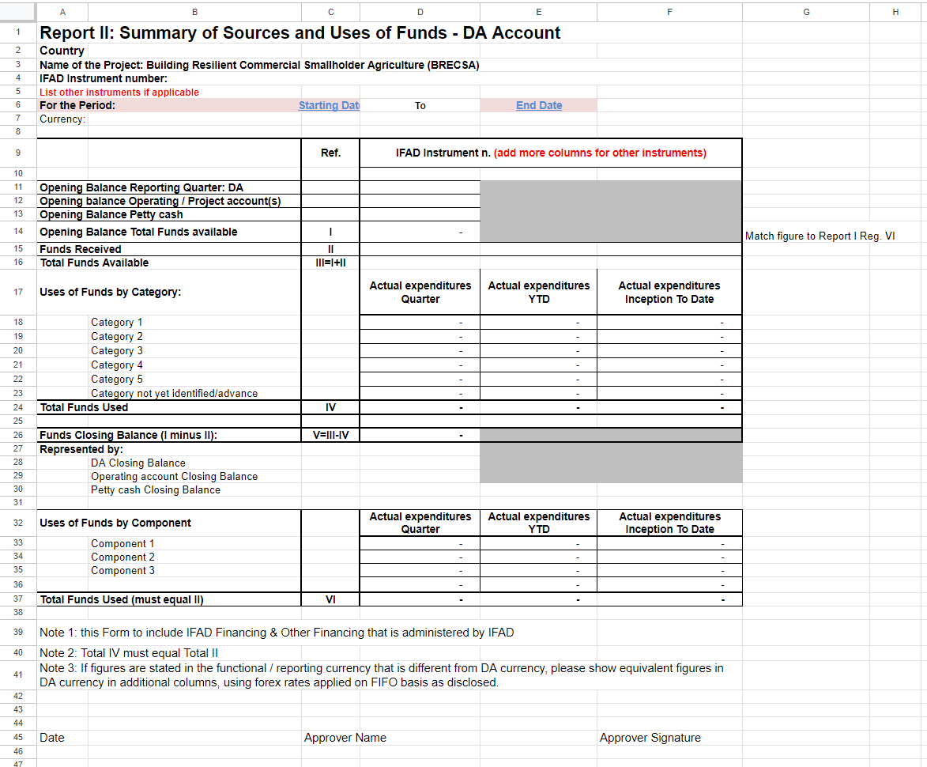
Annexure Sources and Uses of Funds

All Opening Balances and “Start Date” and “End Date” filed will be manual rest will be generated automatically.

Annexure Variance Analysis Quarter
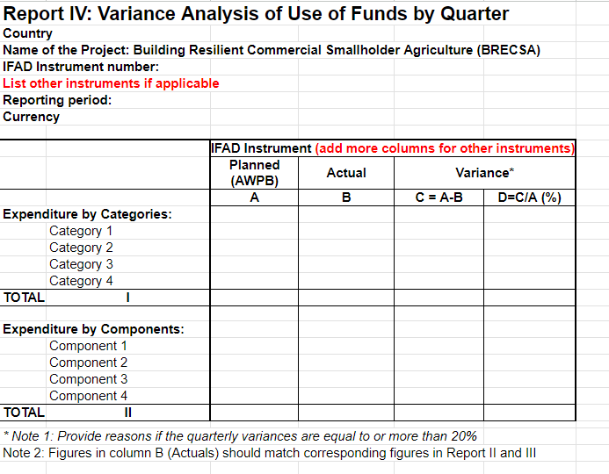

Select Quarter and the report should be auto generated

Annexure Variance Analysis FY
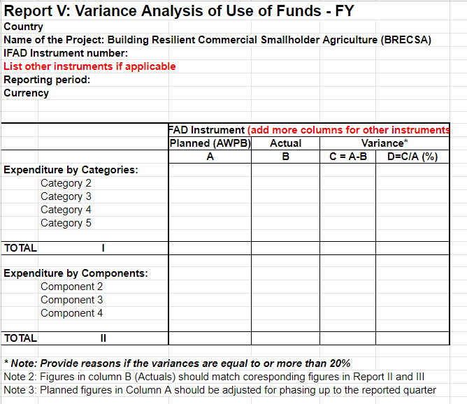

Select Project Year (PY) and the report should be auto generated

Annexure Variance Analysis Cumulative.
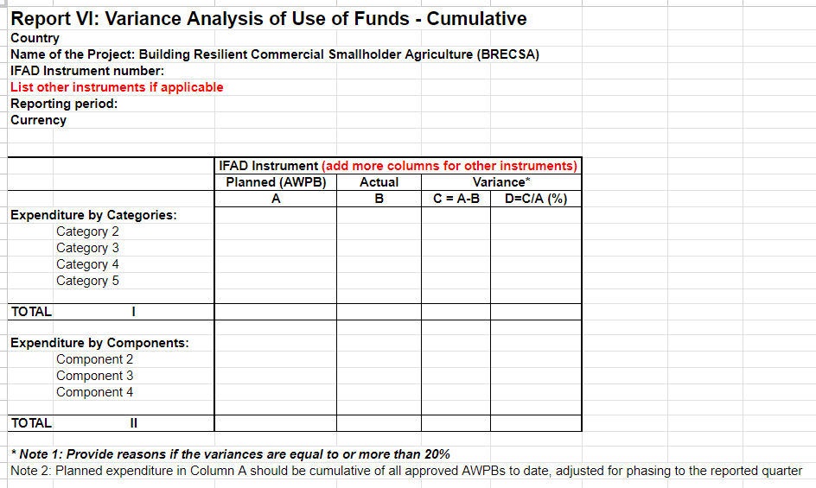

Start Date and End Date Will be manually entered and the report should be generated

Annexure Project Goal
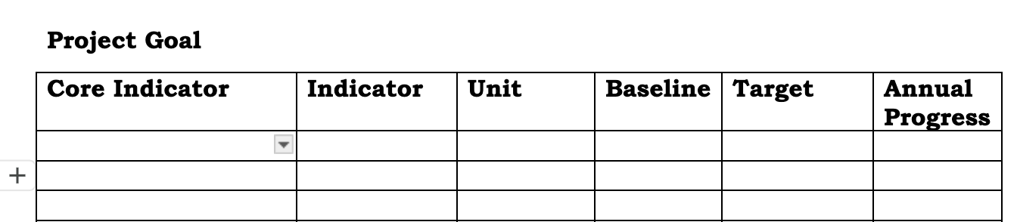

Annexure Project Objective format
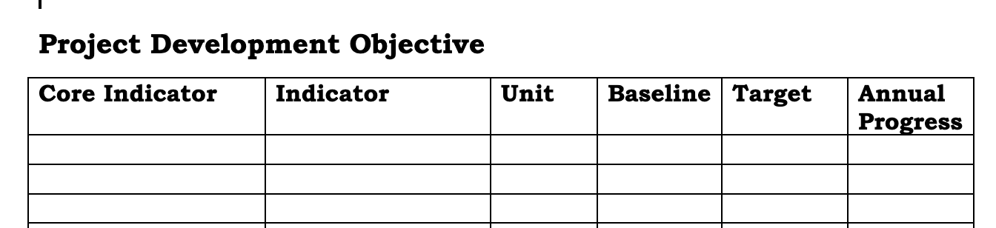

Annexure. Project Outreach format

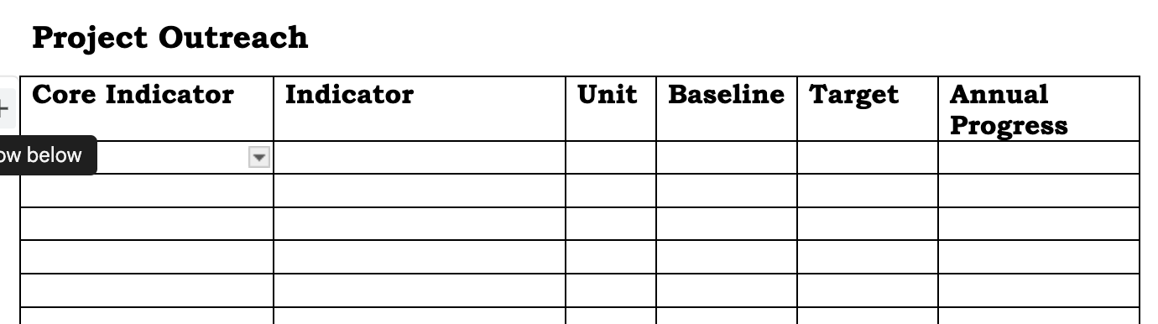

Annexure Project Outcome Format.
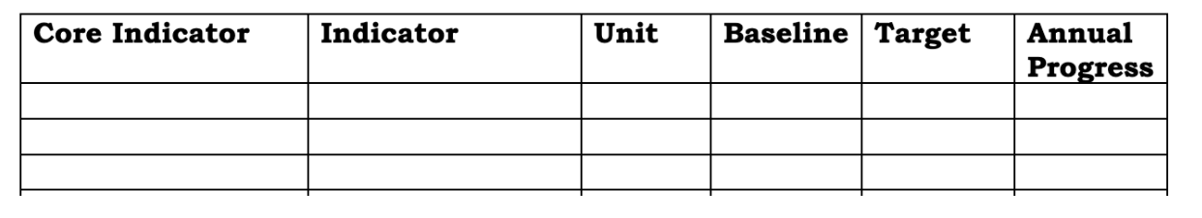

Annexure Project Output Format

